📊 Bank Marketing Campaign Analysis
1. Project overview
This project analyzes a bank marketing dataset to identify key drivers of customer subscription behavior and to provide data-driven recommendations for improving campaign effectiveness.
The project combines data cleaning and transformation using MySQL with interactive visualization using Power BI, following an end-to-end analytics workflow similar to real-world business environments.

2. Business Objectives
- Identify factors influencing customer subscription to term deposits
- Evaluate the effectiveness of marketing campaigns
- Analyze customer demographics and financial behavior
- Optimize call duration and campaign frequency
- Provide actionable insights to support marketing decision-making

3. Dataset Description
The dataset contains historical bank marketing campaign data with the following key attributes:
- Customer Demographics: age, job, salary, marital, education, marital-education
- Financial Information: account balance, housing loan, personal loan, default status
- Campaign Information: call duration, number of contacts (campaign), contact method, month
- Previous Campaign Outcome: success, failure, unknown
- Target Variable: term deposit subscription (yes/no)
Total records: ~45,000 customers

4. Data Cleaning & Transformation (MySQL)
Data preparation was performed using MySQL to ensure accuracy, consistency, and usability before visualization.
4.1 Data Quality Issues Identified
- Checked for Missing, Invalid, or Inconsistent Values
- Checked Unique / Distinct Values in category columns
- Checked Numeric Ranges
4.2 Cleaning Steps
Handling Missing & Unknown Values
- Trimmed string data types to avoid heading and tailing space issues
- Retained unknown categories where removal could bias results
- Checked the duplicates
Feature Engineering
- Created age categories (Young, Adult, Mid-age, Senior)
CASE
WHEN age < 25 THEN 'Young'
WHEN age BETWEEN 25 AND 45 THEN 'Adult'
WHEN age BETWEEN 46 AND 60 THEN 'Mid-age'
ELSE 'Senior'
END AS age_category,
- Grouped salary into Low, Medium, High segments
ALTER TABLE bank_cleaned
ADD COLUMN salary_group VARCHAR(20);

UPDATE bank_cleaned
SET salary_group = CASE
WHEN salary < 50000 THEN 'Low'
WHEN salary BETWEEN 50000 AND 100000 THEN 'Medium'
ELSE 'High'
END;
Data Standardization
- Converted target variable into binary-friendly format
- Ensured numeric fields had consistent units
- Standardized the inconsistent data in job column
UPDATE bank_cleaned
SET job = 'Admin'
WHERE job = 'Admin.';
5. Data Analysis (sql)
• Bank Marketing (Exploratory Data Analysis (EDA))
- Age Category Distribution
- Subscription Rate
- subscription rate by (education, job, marital status, age category and job, age category and campaign effect)
• Campaign Effectiveness Analysis
- Contact Method
- Best performing months
- impact of call duration
- Number of campaign contacts
- Previous campaign outcome
• Customer Financial Behaviour
- Customers with personal loan and housing loan
- Balance segmentation
- Deposit outcome by balance

6. Visualization & Dashboard Design (Power BI)
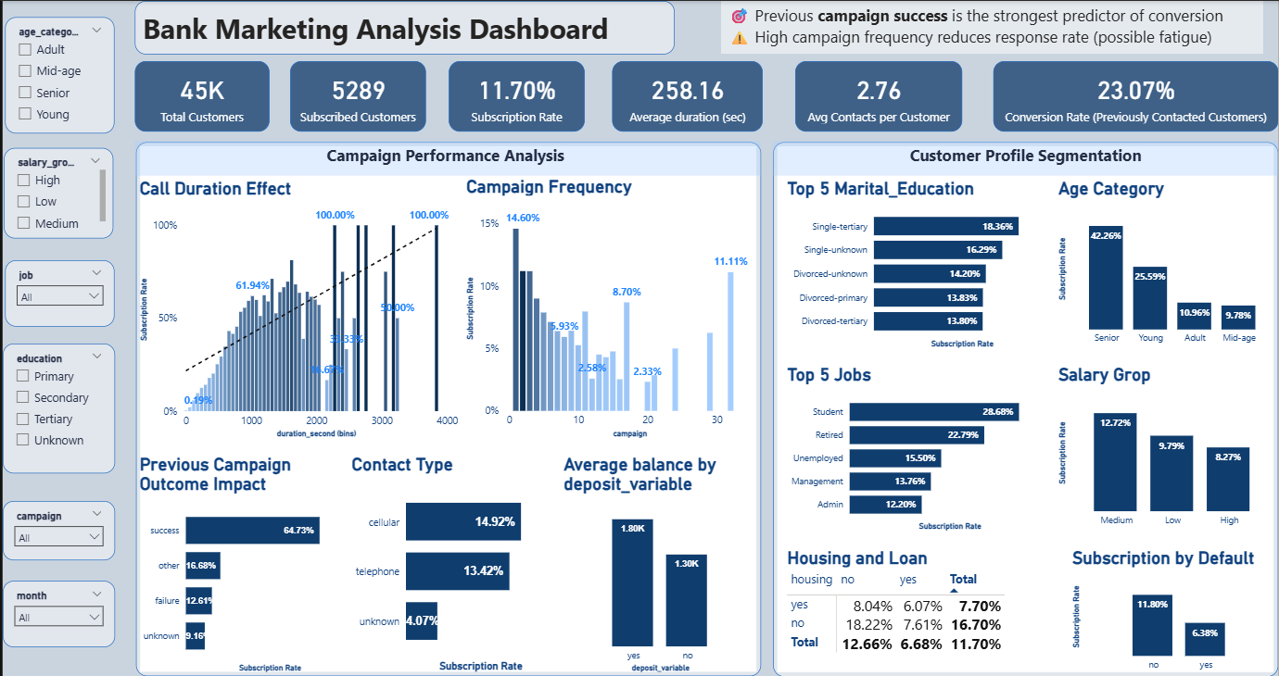
Dashboard Purpose
The Power BI dashboard was designed to support marketing managers and executives by providing:
- High-level performance KPIs
- Customer segmentation insights
- Campaign effectiveness analysis
Dax
- Total Customers
- Total Customers = COUNTROWS(Bank_marketing_cleaned_data)

- Subscribed Customers

- Subscribed Customers =
- CALCULATE (
- COUNTROWS ( 'Bank_marketing_cleaned_data' ),
- 'Bank_marketing_cleaned_data'[deposit_variable] = "yes"
- )

- Subscription Rate
- Subscription Rate =
- DIVIDE (
- [Subscribed Customers],
- [Total Customers],
- 0
- )

- Conversion Rate (Contacted)

- Campaign Success Rate =
- DIVIDE (
- CALCULATE (
- COUNTROWS('Bank_marketing_cleaned_data'),
- 'Bank_marketing_cleaned_data'[deposit_variable] = "yes",
- 'Bank_marketing_cleaned_data'[pdays] <> -1
- ),
- CALCULATE (
- COUNTROWS('Bank_marketing_cleaned_data'),
- 'Bank_marketing_cleaned_data'[pdays] <> -1
- ),
- 0
- )

Key KPIs
- Total Customers
- Subscribed Customers
- Subscription Rate (%)
- Average Call Duration (seconds)
- Average Campaign Contacts
- Conversion Rate (Previously contacted customers)
Key Visual Sections
Campaign Performance Analysis
- Call duration vs subscription rate
- Campaign frequency impact
- Previous campaign outcome influence
Customer Profile Segmentation
- Subscription rate by age category
- Top jobs and education groups
- Salary group comparison
Financial Behavior Analysis
- Average balance by deposit subscription
- Subscription by housing loan and personal loan
- Default status impact
Interaction Controls
- Slicers for age category, salary group, job, education, month, and campaign

6. Key Insights
- Previous campaign success is the strongest predictor of subscription
- Longer call duration significantly improves conversion probability
- High campaign frequency leads to reduced response rates (customer fatigue)
- Seniors, students, and medium salary customers show higher subscription rates
- Cellular contact performs better than telephone contact
- Customers without housing or personal loans are more likely to subscribe

7. Business Recommendations
- Retarget customers with successful previous campaign outcomes
- Optimize call duration to balance engagement and efficiency
- Reduce excessive campaign contacts to avoid customer fatigue
- Focus on high-performing customer segments
- Prioritize cellular channels for outreach

8. Limitations
- Dataset reflects historical behavior and may not represent current conditions
- No campaign cost or revenue data available to calculate ROI
- Customer preferences may change over time

9. Future Enhancements
- Build a predictive model to estimate subscription likelihood
- Incorporate campaign cost and ROI analysis
- Perform seasonal and time-series analysis
- Integrate A/B testing results for campaign optimization

10. Conclusion
This project demonstrates an end-to-end data analytics workflow, from data cleaning in MySQL to interactive visualization in Power BI. The analysis provides actionable insights that can help improve marketing efficiency, customer targeting, and overall campaign performance. The project highlights practical skills in SQL, data analysis, dashboard design, and business communication.

